Q18. Steps of Create and Manage Menu in WordPress and Joomla CMS
Part A: WordPress
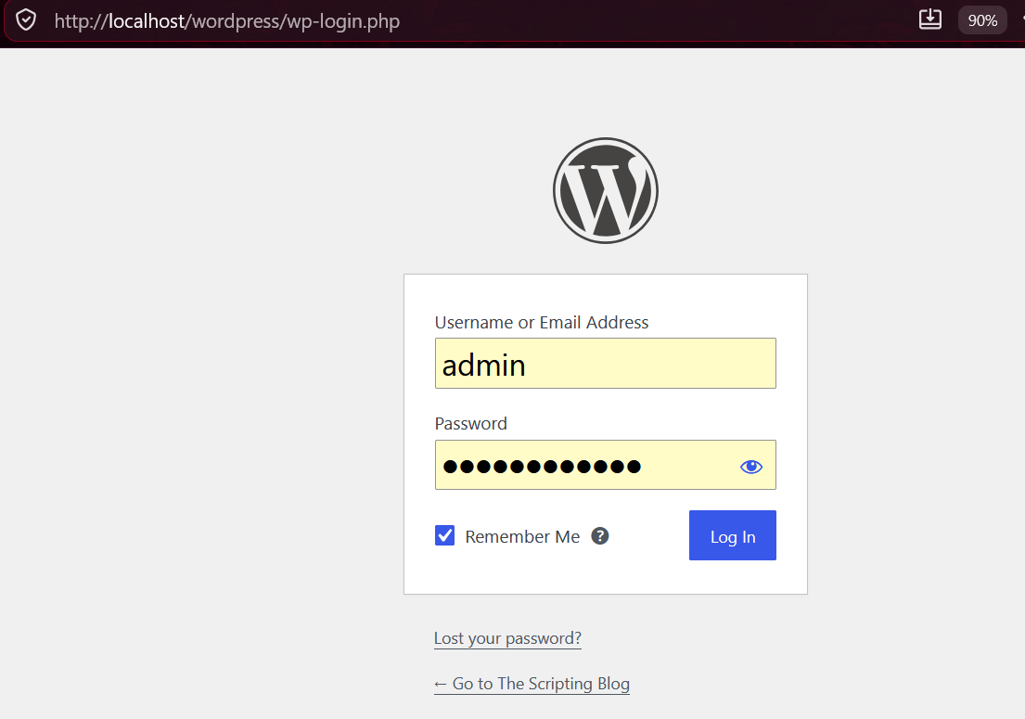
- Login to http://localhost/wordpress/wp-admin.

- Go to Appearance > Menus.
- Click Create a New Menu, give it a name (e.g. Main Menu).
- Select Pages/Posts from the left panel and click Add to Menu.
- Drag items to reorder them.
- Check the box under Menu Settings to set it as the Primary Menu.
- Click Save Menu.
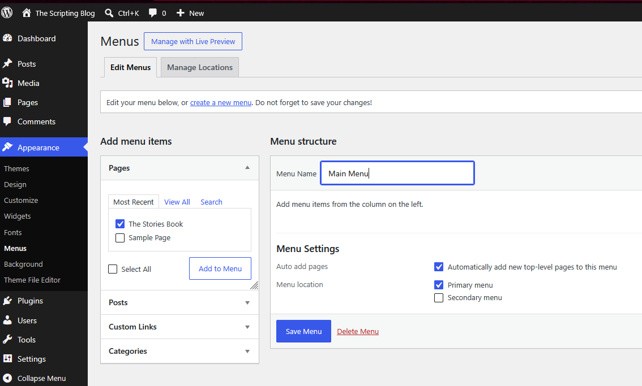

Part B: Joomla
- Login to http://localhost/joomla/administrator.
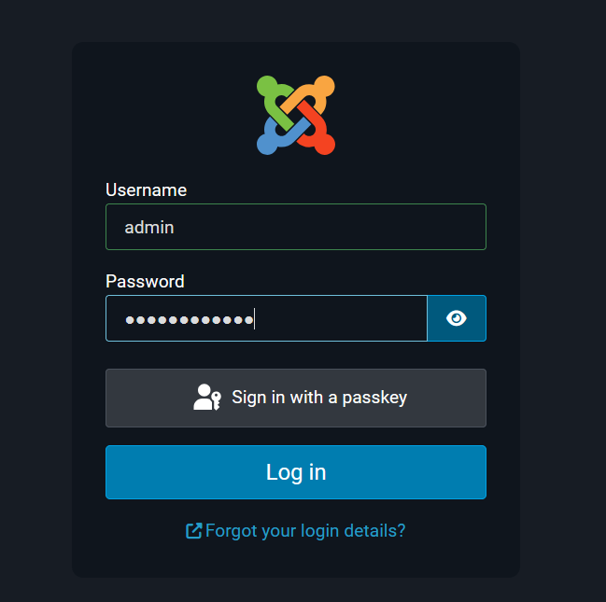

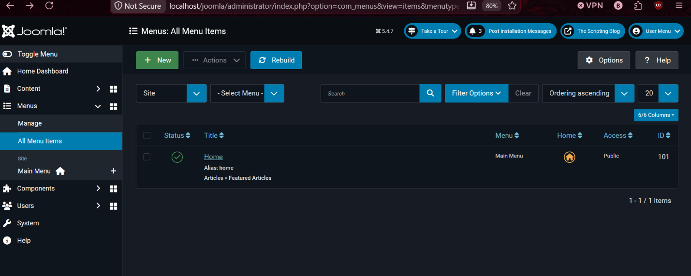
- Go to Menus > All Menu Items > Add New Menu Item.

- Enter a menu title.
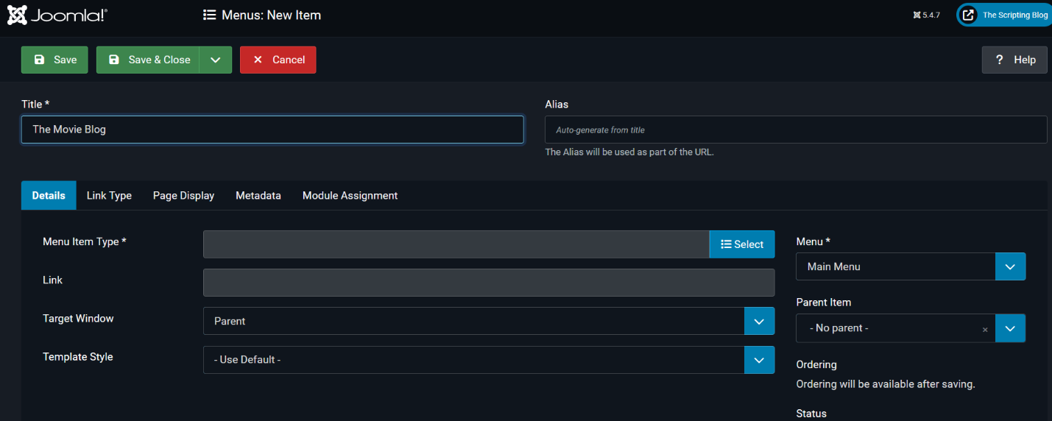
- Select Menu Item Type as Single Article and choose the article.
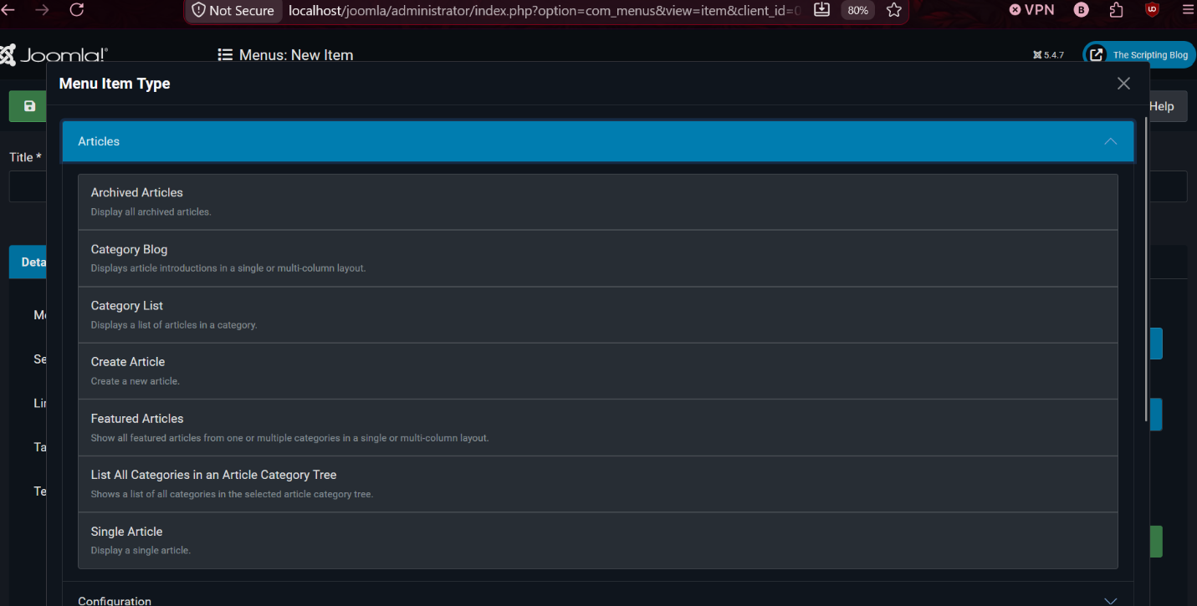
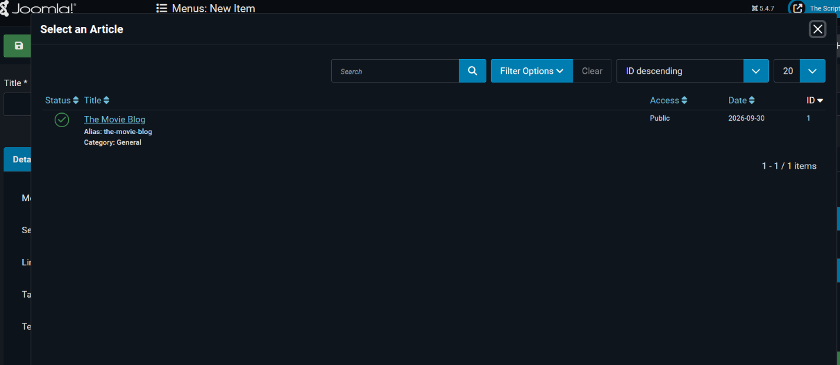

- Click Save & Close. 